Lecture 8 - Exercises with Solutions

Question 1: Select optimal columns for biomolecule purification

What columns or chromatography techniques would you need to complete the following biomolecule purification experiments:

a. Separate two proteins based on differing molecular weights
Answer: Size-exclusion (or gel filtration) column (e.g., Superose-based resin)

b. Separate a mixture of lipids based on differing hydrophobic properties
Answer: Hydrophobic interaction chromatography (e.g., silica column)

c. Separate a mixture of DNA molecules that have different lengths and resulting negative charge (e.g., 20, 40 and 60 nucleotide base pairs)
Answer: Anion-exchange chromatography (e.g., DEAE matrix), or size-exclusion

d. Purify a tagged protein from other cellular biomolecules
Answer: Affinity chromatography (specific column is dependent on the tag selection)

Question 2: Select an optimal expression system for your protein

What expression systems would you choose for the expression of the following proteins? Why or why not and explain:

a. 12 kDa single-domain protein of bacterial origin, residing in cytoplasm (example: KaiB oscillator protein)
Answer: Given the relatively small size, bacterial origin, and the lack of post-translational modifications (none mentioned in the question), E. coli would be the preferred cell system, although other systems can also be tested.

b. 280 kDa multi-domain protein of human origin, residing in cytoplasm (example: mTOR kinase)
Answer: In theory, this protein can be expressed in any system, but given the mammalian origin and multi-domain nature of the protein, preference should be given to mammalian or insect cells since they have sufficiently complex folding machinery (e.g., chaperones) to produce functional protein.

c. 15 kDa disulfide-linked chemokine of mouse origin, secreted outside the cell (example: Interleukin 11)
Answer: Given the small size, need for secretion, and disulfide bond formation, yeast would represent an ideal system for the production of this protein. E. coli cannot be used due to the lack of optimal secretory machinery and issues with formation of correct disulfide bond network. Insect cells and mammalian cells can also be applied for the production of this protein, given the biochemical properties and mouse origin.

d. 249 kDa multidomain, N-glycosylated, transmembrane protein of human origin (example: integrin)
Answer: Given the relatively large size, transmembrane localization and need for glycosylation, this protein would be ideally suited for mammalian cells. Insect cells can also be considered for this expression, although N-linked glycosylation is slightly different compared to mammalian cells, which could be problematic for some proteins. Yeast system may work in theory, but the multidomain nature of this protein would present a considerable challenge for these relatively simple cells. Still, many complex transmembrane proteins are produced in yeast. E. coli does not have the glycosylation machinery so it cannot be applied here.

e. 194 MDa virus of bacterial origin (example: T4 bacteriophage)
Answer: Viruses are most commonly produced in cells that match the origin species since they have all the necessary cellular machinery to correctly produce and assemble the virus. So in this case you should select bacterial cells (e.g., E. coli). Similarly, mammalian or insect viruses should be produced in mammalian or insect cells from tissues matching those at which the viruses replicate (e.g., lung cell lines for respiratory viruses).

Question 3: Affinity purification

You would like to purify a human intracellular protein (Protein X) which has a molecular weight of 40 kDa and is associated to several diseases. Based on sequence analysis and AlphaFold structure prediction, you conclude that it consists of a single domain and is not expected to undergo any post-translational modifications. Further, the protein does not have any cysteine residues that can form disulfide bridges. You added a poly-histidine tag to the C-terminus of the protein to facilitate purification.

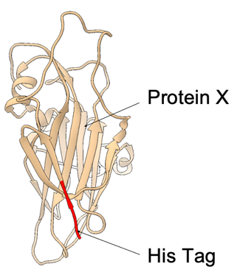

a. Which expression system would you first test for this protein and why?
Answer: In theory, all expression systems we mentioned in class can be used to produce this protein. However, given the low molecular weight, single-domain nature and absence of predicted post-translational modifications, the first choice should be E. coli as it is the simplest, cheapest and most versatile system.

- b. Following the expression in the host chosen previously, you continue with affinity chromatography in order to purify the protein. Describe the specific type of affinity purification you’ll employ and identify which part of the protein is required for this method. Additionally, explain the working principle of this technique and specify the type of column you’ll be using.

Answer: His-tag Affinity chromatography purification. For this method a column containing Ni-NTA groups conjugated to a resin will bind to groups enriched in histidine residues (i.e., his-tag). The proteins that do not contain a his-tag will wash through the column while the protein of interest, which contains a his-tag, will stick to the column. It will be eluted in a next step with imidazole which out-competes and displaces the his-tags bound on the resin.

c. Select the minimal set of necessary buffer components that should be included in the Elution Buffer for the his-tag purification step?
Answer:
Reagent | Yes | No | Why?
20mM Tris-HCl | X |  | Buffer capacity to maintain the pH
0.1% Triton-X |  | X | This is a detergent. Not needed for this.
150mM NaCl | X |  | Salt to mimic physiological conditions.
5mM DTT |  | X | Reducing agent. Not needed in this case due to the lack of disulfides in the protein
10mM Ribose |  | X | Carbohydrates can stabilize certain proteins. There is not enough information to justify its use here.
20% Glycerol |  | X | Organic solvents can help to prevent protein aggregation. Insufficient information to justify its use here.
0.1mM Imidazole |  | X | Imidazole is the eluting agent, but it needs to be at a much higher concentration to have effect.
500mM Imidazole | X |  | Needed to elute the protein from the Ni-NTA resin

d) For the His-Purification you obtain the following chromatogram. Label the peaks 1, 2 and 3 and explain what proteins are in each peak. In blue you can follow the UV absorbance of the protein at 280 nm and in green the concentration of imidazole. Was this a step-wise or a gradient-based elution with imidazole?

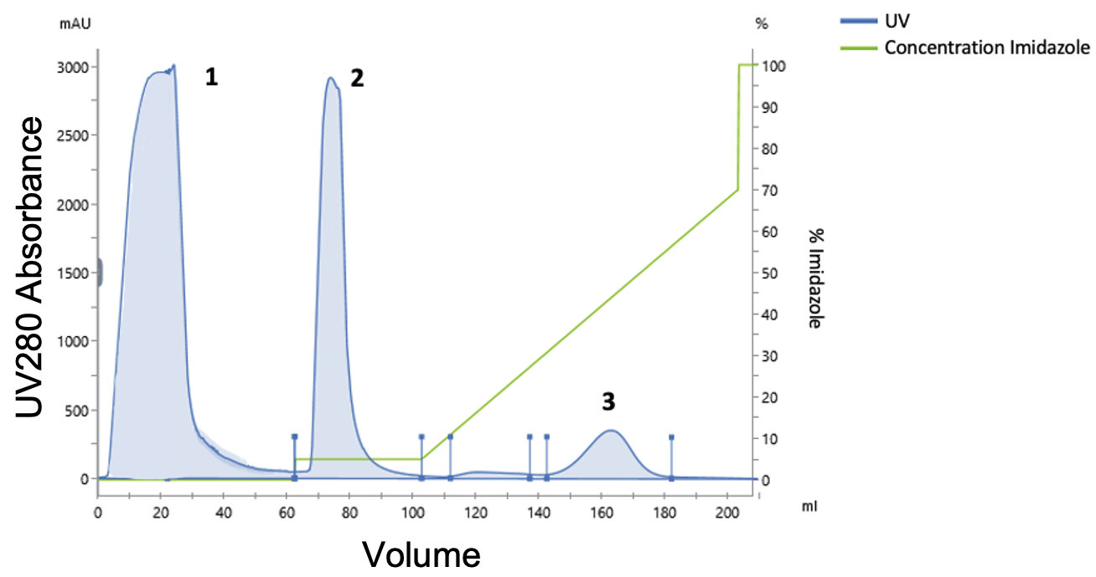
Answer:
Peak 1: Protein flow through Cellular proteins that do not bind to the His-column.
Peak 2: Cellular proteins that bind the nickel-column with low affinity probably because they contain some exposed histidine residues. They are eluted with a low concentration of imidazole (5% of the 500mM imidazole stock). This represents a wash step.
Peak 3: Protein of interest eluted using 30-60% of the 500mM imidazole stock solution. This represents an elution step.
Wash step (Peak 2): Step-wise
Elution step (Peak 3): Linear gradient
e) To assess the purity of your protein of interest, you decide to run an SDS-PAGE under reducing conditions. You load the gel with: a protein ladder, the original lysate from E. coli that you injected into the His-column ("Input"), and small amounts of samples taken from fractions corresponding to peaks 1, 2, and 3. Examine the gel: Which fractions contain the protein of interest? Does it match the predicted molecular weight based on the sequence? Evaluate whether the purification was successful and what could be improved next time?

Answer: The Input fraction, the flow through and the fraction corresponding to Peak 3 contain the protein of interest. Based on the molecular weight standards (“Ladder”), the protein appears to be at 40kDa which matches the expected MW based on the amino-acid sequence. The purification was successful because the protein in peak 3 is pure without any detectable contaminant proteins. However, there is some remaining protein in the flow through (Peak 1) that did not bind to the column. This could be due to a number of reasons: binding capacity of the column could be exceeded, protein could be partially misfolded, loading buffer components are removing Ni from the resin, pH of the buffer is too low, very fast flow rate when loading the protein to the column etc. By further optimizing the buffer conditions and the chromatography steps this could potentially be improved to increase the yield of the purification and collect 100% of the protein that is expressed.

f) You suspect that your protein (Peak 3 from the previous step) may be partially aggregated, which will lead to problems with downstream structural and functional analyses. So you decide to separate the monomeric and aggregated forms of the protein using Size-Exclusion-Chromatography. How does size-exclusion chromatography work? Looking at the chromatogram, where is the aggregated and where is the soluble protein?
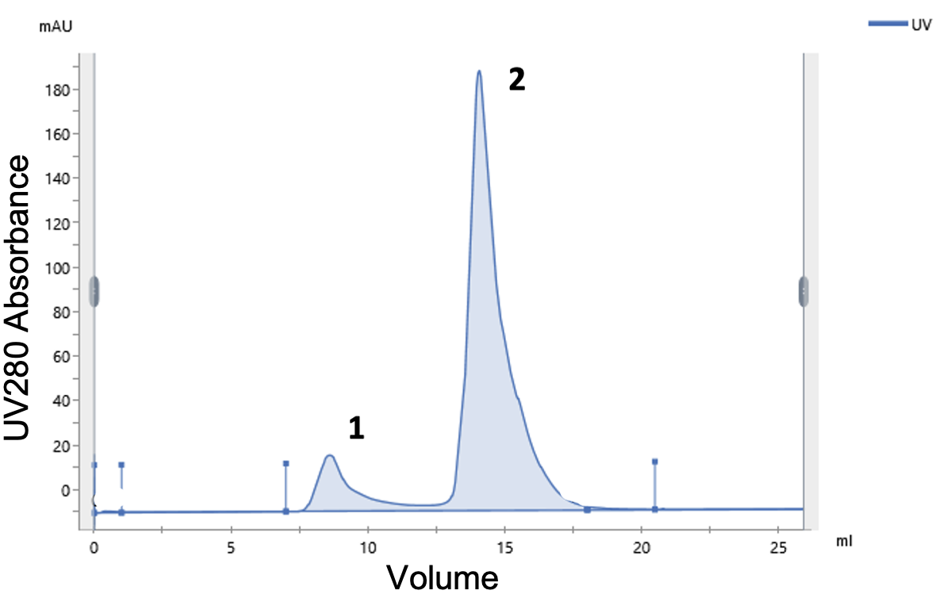

Answer: Size exclusion chromatography is used to separate proteins by size. The resin of the column consists of spherical beads which contain pores of a specific size distribution. Smaller proteins diffuse into the pores and therefore the passage through the column takes longer (higher elution volume). Larger proteins diffuse less into the pores and therefore elute faster (lower elution volume). Consequently, the proteins are separated by size with the large proteins eluting first and the small one last.

Aggregated proteins have a larger radius and a higher molecular weight and therefore they travel faster through the SEC column. The aggregated protein is therefore in the peak 1 and the folded protein of interest in peak 2.

Question 4: Separating proteins by charge

You are working with a Protein Y with a molecular weight of 50 kDa that has a pI of 5.5. After the initial affinity purification you realize that the protein is contaminated with other protein species, so you decide to increase the purity of your protein by separating it based on charge, using ion-exchange chromatography.

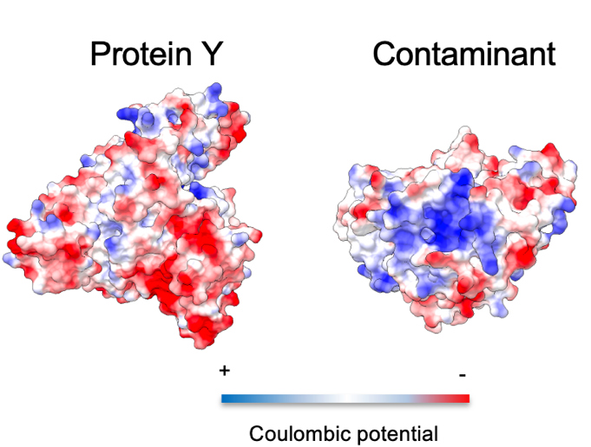

- Using a buffer of ph=7.5 what is the net charge of the protein? What subtype of column would you use to bind it?
Answer: The pH of the buffer is higher than the pI of the protein, therefore it is negatively charged. Hence, you should use an anion exchange column to bind the protein as the resin of the column is positively charged and binds negatively charged proteins.

- What are the different ways that you can use elute proteins from this type of column?
Answer: Proteins can be eluted from an ion-exchange column either by:
(1) Gradually changing the pH of elution buffer – The protein will elute once the pH of the buffer drops below the pI value of the protein, which is 5.5.
(2) Gradually increasing salt (i.e., NaCl) concentration in the elution buffer – The proteins with elute depending on the ionic interactions formed with the resin. The stronger the ionic interaction -> the higher the concentration of salt needed to displace the protein

- You elute the protein from the column using a linear gradient of NaCl and get the following chromatogram. In the chromatogram you follow the protein by looking at its absorption at 280 nm (UV). By increasing the relative percentage of the “elution buffer” (green) you slowly increase the salt (NaCl) concentration loaded onto the column which triggers the elution of the protein. You can follow the increase in salt concentration by looking at the increase in conductivity (orange). You observe that the contaminating proteins elute before your protein of interest. Why is that the case? What does the position of the peak depend on when eluting with salt?
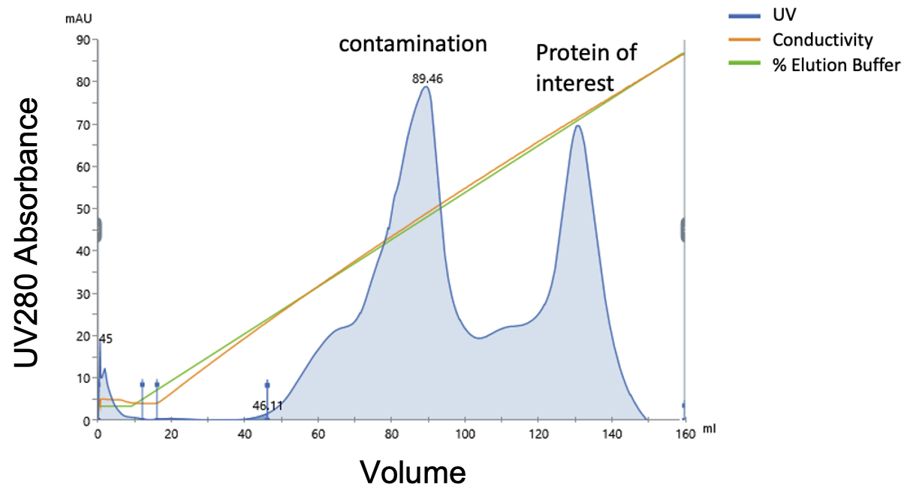
Answer: The location of the peak will depend on the relative strength of interactions formed between each protein species and the anion-exchange resin, which will be a function of the content of positively and negatively charged groups in the protein at the buffer pH (in this case 7.5), the relative sizes of each protein species (i.e., total number of amino-acids) and even their 3D structures. The stronger the ionic interaction -> the higher the concentration of salt need to displace the protein.
In this case the contaminating proteins form weaker interactions with the resin compared to the protein of interest, which is why they elute at lower salt concentrations (lower % of elution buffer).
Question 5: Purification of strep-tagged proteins

You are working with an enzyme with the predicted molecular weight of 30 kDa (based on amin-acid sequence). In nature this protein needs to dimerize in order to be in its’ functional state. The dimeric state is further stabilized by 2 disulfide bonds formed between the monomers.
The protein has been engineered with a C-terminal Strep-Tag and recombinantly expressed in E. Coli.

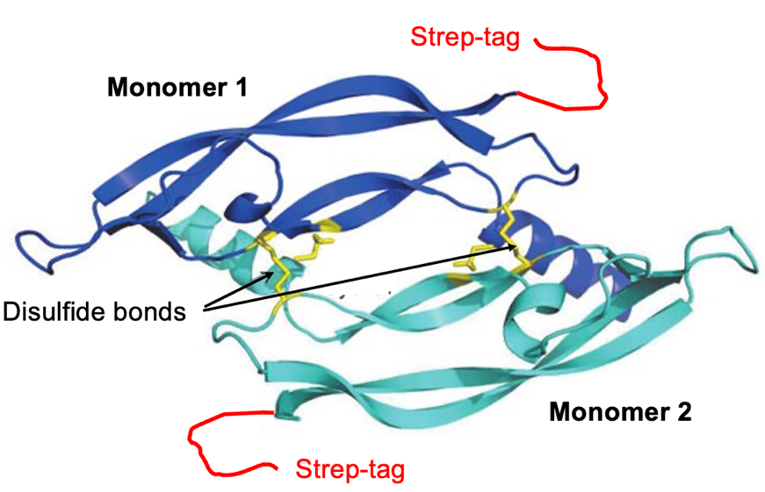

- What type of affinity column would you use to purify this protein?
Answer: For the Strep-tag a streptavidin coated column is used. The protein is eluted with biotin.

- Select the minimal set of necessary buffer components that should be included in the Elution Buffer for this purification step?
Answer:
Reagent | Yes | No | Why?
20mM Phosphate buffer (pH 7.5) | X |  | Buffer capacity to maintain the pH
0.1% Triton-X |  | X | This is a detergent. Not needed for this.
150mM NaCl | X |  | Salt to mimic physiological conditions.
10mM Cellulose |  | X | Carbohydrates can stabilize certain proteins. There is not enough information to justify its use here.
5mM DTT |  | X | Reducing agent. Must be avoided in this case because of disulfide bonds.
20% Ethanol |  | X | Organic solvents can help to prevent protein aggregation. Insufficient information to justify its use here.
20mM Biotin | X |  | Biotin is the eluting agent needed to dissociate the protein from streptavidin column
500mM Imidazole |  | X | Not needed for this purification. Used with Ni-NTA
3M MgCl₂ |  | X | Not needed for this purification. Used with antibody columns

- After purification you obtain the following chromatogram which shows more peaks than you anticipated. To determine which peak contains the pure protein you run small amounts on an SDS PAGE gel under reducing conditions (+ DTT). Which peak contains the pure protein of interest? Please explain.
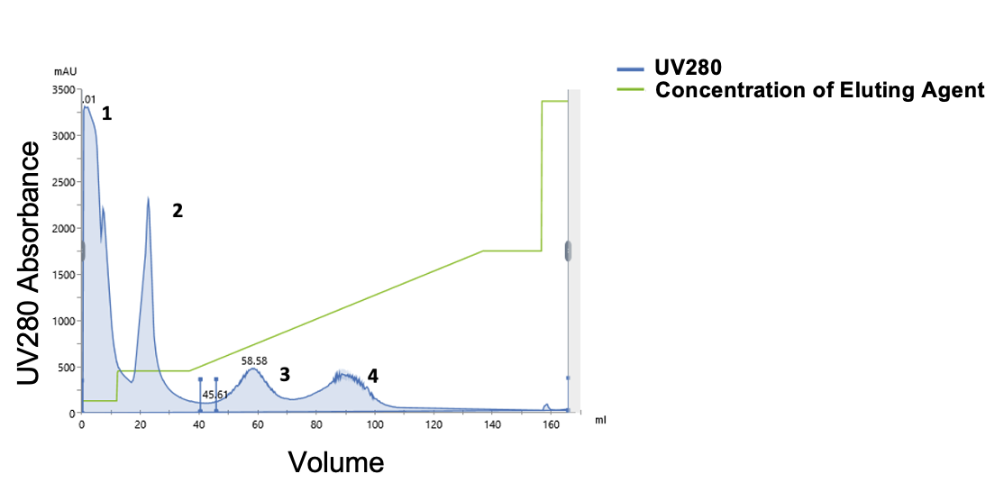
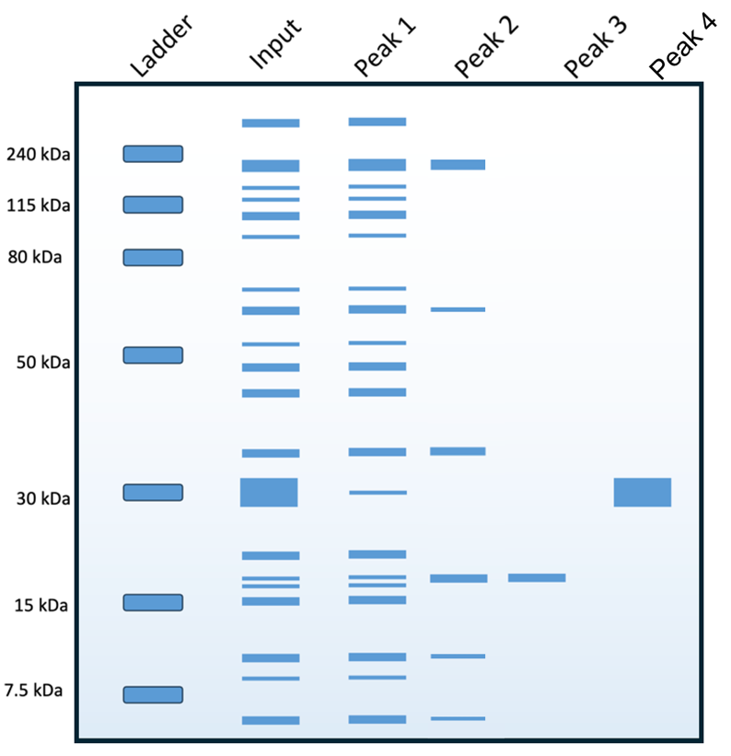

Answer:
Peak 4 elutes at the highest biotin concentration compared to all other peaks, and the corresponding protein runs on the SDS PAGE gel as a single clean band at molecular weight of 30kDa, which is expected for your target protein based on amino-acid sequence. The presence of DTT (reducing conditions) assures that all disulfide bridges will be reduced which is why there are no bands corresponding to dimers (~60kDa) or other oligomeric states of this protein whose existence would be dependent on disulfide bonds.
Altogether, Peak 4 appears to contain our protein of interest.

- To separate different oligomeric states of the protein (monomer vs dimer) you perform size-exclusion chromatography. In the chromatogram you see two peaks and you get very excited because you assume that one of the peaks belongs to the dimeric active form of the enzyme. Which peak corresponds to the monomer and which peak to the dimer based on the elution volume?
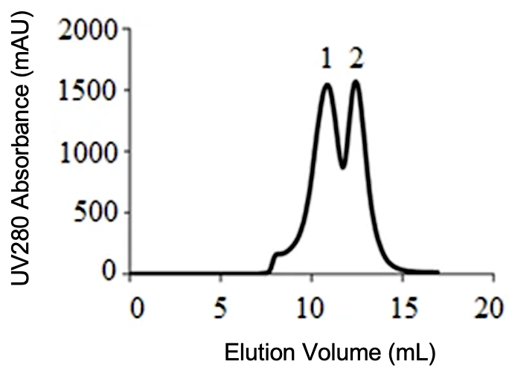
Answer:
The dimer is in peak 1, the monomer in peak 2. The dimer elutes earlier as it is bigger and on a SEC column large proteins elute before small ones.

- You take a small amount of each peak and denature it under reducing (+DTT) and non-reducing (-DTT) conditions, followed by SDS PAGE analysis. The results are shown below. What can you say about the status of inter-monomeric disulfide bonds in Peak 1 and Peak 2? How do these results correlate to size-exclusion chromatography in terms of the oligomeric state?

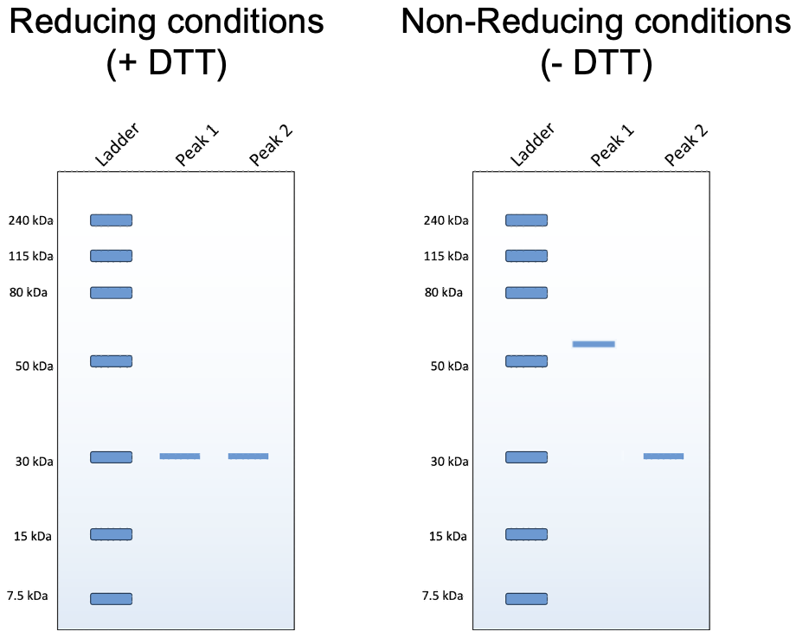

Answer:
DTT is a reducing agent, and its presence during protein denaturation will disrupt disulfide bonds leading to the separation of dimers into monomers. Therefore, when DTT is present, your protein will run as a single band at ~30kDa regardless of the oligomeric state it had prior to denaturation. This is why in both cases, Peak 1 and Peak 2, we observe a single protein band corresponding to the monomeric protein.

When the reducing agent is not included, the disulfide bridges are preserved. In the case of Peak 1, we observe that the protein band is now located at 60kDa which corresponds to the dimeric state, held together by the disulfide bonds. In the case of Peak 2, the protein band is still located at 30kDa which indicates that this sample did not exist as a dimer prior to gel loading.

This is consistent with the size-exclusion chromatography in that Peak 1 appears to contain a dimeric form of your protein while Peak 2 is expected to be monomeric based on the elution volumes.

